

DSA Assignment 02

Name: Syed Muhammad Raza Ali

Enrolment: 02-134231-028

Course: DSA

Faculty: Miss Lubna Siddiqui

**Scenario CLO-4, PLO-4, C6**

*N* people, numbered 1 to N are sitting in a circle. Starting at person 1, a hot potato is passed. After M passes the person holding the hot potato is eliminated, the circle closes ranks and the game continues with the person who was sitting after the eliminated person picking up the hot potato. The last remaining person wins. Thus if *M=0* and *N=5*, players are eliminated in order and player 5 wins. If *M=1 and N=5* the order of elimination is 2,4,1,5

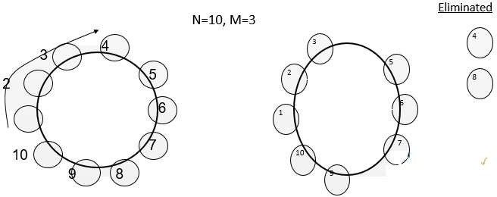

**Design** two different algorithms with different approaches to solve the above problem.

**Create** a code in C++ to implement both algorithms by applying appropriate data structure for general values of M and N.

Test your program with three different values of *M* and *N*.

First Approach: Circular Linked List

Code:

#include <iostream>

using namespace std;

struct player {

int data;

player* next;

};

int eliminate(int N, int M) {

if (N <= 0 || M < 0) return -1;

player* head = new player;

head->data = 1;

head->next = nullptr;

player* current = head;

for (int i = 2; i <= N; i++) {

player* newplayer = new player;

newplayer->data = i;

newplayer->next = nullptr;

current->next = newplayer;

current = newplayer;

}

current->next = head;

player* prev = current;

while (current->next != current) {

for (int i = 0; i < M; i++) {

prev = current;

current = current->next;

}

prev->next = current->next;

player* nextplayer = current->next;

delete current;

current = nextplayer;

}

int winner = current->data;

delete current;

return winner + 1;

}

int main() {

int N, M;

cout << "Enter the number of people (N): ";

cin >> N;

cout << "Enter the elimination step (M): ";

cin >> M;

int winner = eliminate(N, M);

cout <<winner << " is the winner..." << endl;

return 0;

}

Output:

When M = 1 and N = 5

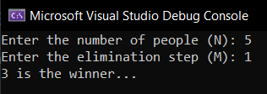

When M = 3 and N = 15

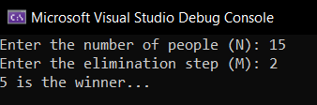

When M = 0 and N = 3

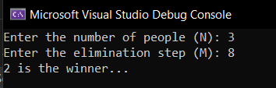

*Second Approach: Recursion*

The Josephus Problem can also be solved by making a recursive function

**Code:**

#include <iostream>

using namespace std;

int eliminate(int N, int M) {

if (N == 1) {

return N;

}

else {

int winner = eliminate(N-1, M);

return (winner +M-1) % N + 1;

}

}

int main() {

int N = 5;

int M = 1;

cout << eliminate(N, M);

return 0;

}

**Output:**

**When N = 15 and M = 7**

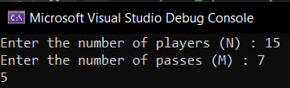

**When N = 20 and M = 13**

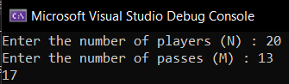

**When N = 6 and M = 1**

